Soul Trains Tech Rider
NOTE: Band setup may varie depending on venue layout and requirments, this can be discussed withthe band prior to their arrival.
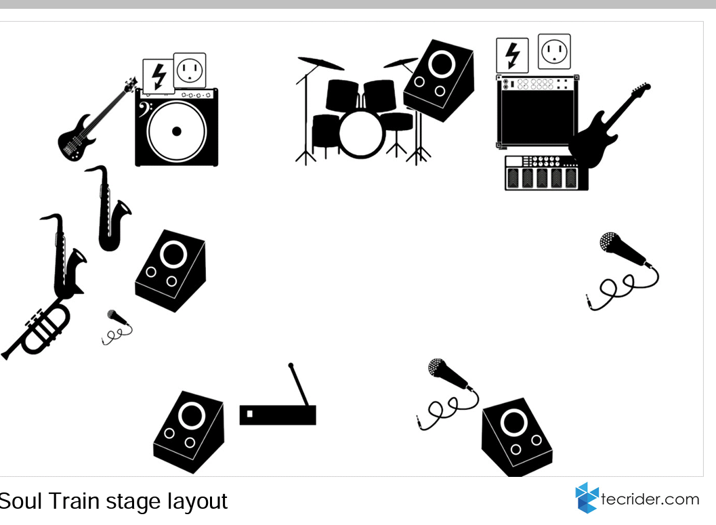

Stage Requirements
Minimum of 5 x 5 metre stage to accommodate 8 piece band
Minimum 6 x 5 metre stage to accommodate 10 piece band
Musicians
Back centre - Drums – 6x drum mics, 1x over head, 1 x floor monitor (Drummer does provide personal inear monitors)
Right Side back – Lead Guitarist – 1 x Amp , 1 x effects board, 1x power source. ( uses inear monitor)
Left side back – Bass Guitarist – 1x amp, or DI , 1x effects board, 1x power source (uses inear monitor)
Brass section
2x monitors required (may operate with 1 )
Left side middle/front – Tenor/Alto Sax- clip on mic (phantom powermrequired)
Left side middle/front – Baritone Sax – clip on mic ( requires phantom power )
Left side middle/front - Trumpet – 1x boom stand, 1x mic

Vocalist
Right side front – Femal lead – 1x front man stand, 1x Shure sm58 mic, 1x monitor. ( prefers to use own stand and mic, may use inear monitor )
Left side front – Male lead – 1x front man stand, 1x Shure sm58 mic, 1x monitor (prefers to use own wireless mic and stand, may use inear monitors )
On occasion depending on venue size and requirements the band may use additional backing vocalist.
Backing Vocalist
2 x monitors require, ( may operate with 1 )
Right side middle/front – Bv 1 – 1x front man stand, 1x Shure sm58 mic
Right side middle/front – Bv2 – 1x front man stand, 1x Shure sm58 mic

Additional information
Upon arrival at the venue, the band would require adequate parking spaces ready available.
Clear and easy accessible entry to and from the venue whilst loading and unloading.
Where possible the band would require suitable changing areas prior to performance.

For more information or to discussions anything prior to the bands arrival regarding set up, you may contact Mark on 07427072194 or email, soultrainband10@gmail.com.
Thank You, we look forward to working with you

